Scott Blick

Scott Murray

Thanh Bui

Ahmed Shogar

Javier Rodriquez

**JGradeBook Project Report**

**Index**

**I. Project Team Model**

**II. Life-Cycle Model**

**III. Diagrams**

1. **Use-Case**
2. **Class Diagram**
3. **Student Collaboration Diagram**
4. **Admin Collaboration Diagram**
5. **Sequence Diagram**

**IV. Summary**

1. **Project Team Model: Modified Chief Programmer**

We used a modified classical chief programmer. There still was a chief programmer in charge of the project, but there was also a manager to help coordinate with the group

* + Scott Blick – Chief Programmer/Project Lead
  + Scott Murray – Backup Programmer
  + Thanh Bui - Secretary
  + Ahmed Shogar – Team Manager
  + Javier Rodriquez – Programmer/Tester

1. **Life-Cycle Model: Rapid Prototyping Model**

We used the rapid prototyping life-cycle to help us explore our options and learn some of the technologies we might use.

1. **Diagrams**
   1. **Use-Case Diagram**

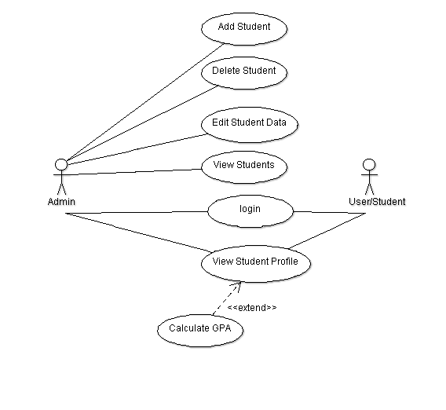

* 1. **Class Diagram**

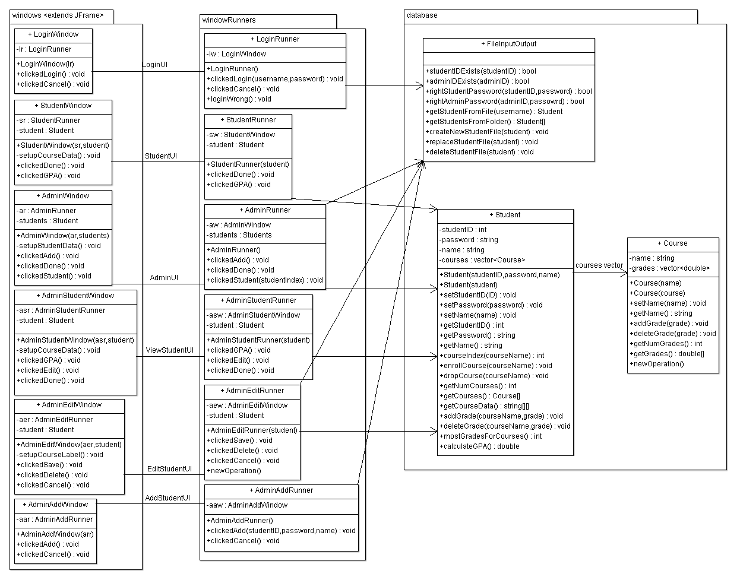

* 1. **Student Collaboration Diagram**

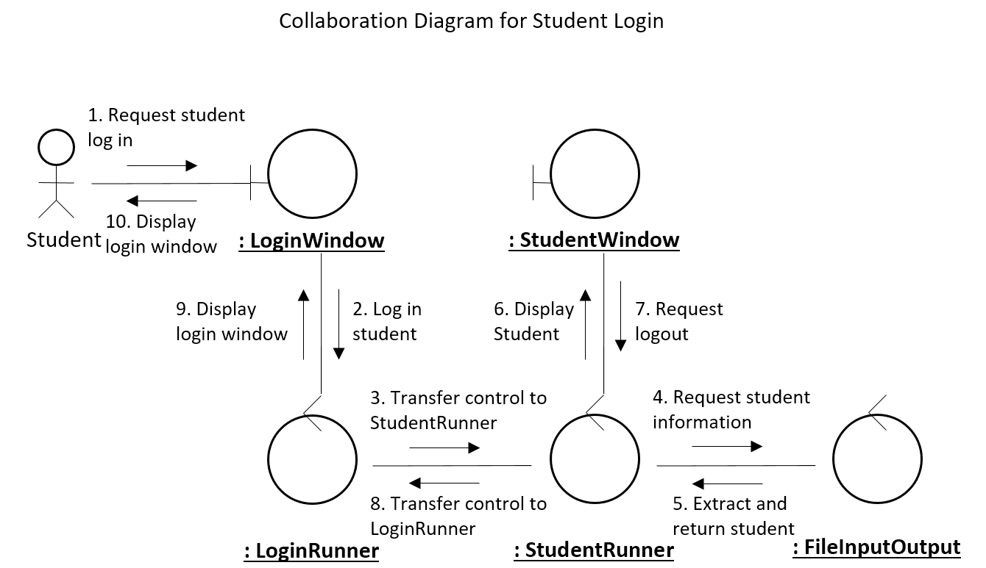

* 1. **Admin Collaboration Diagram**

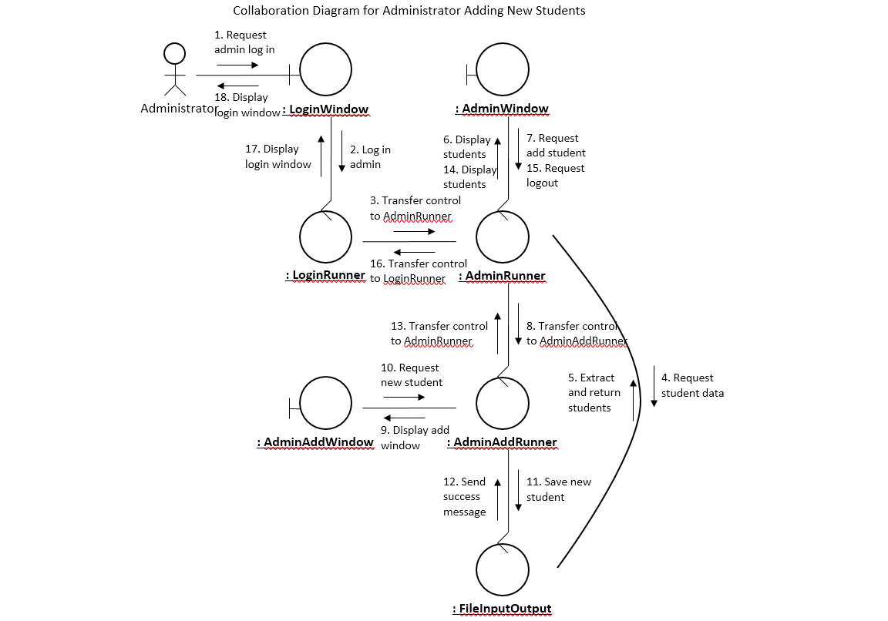

* 1. **Sequence Diagram**

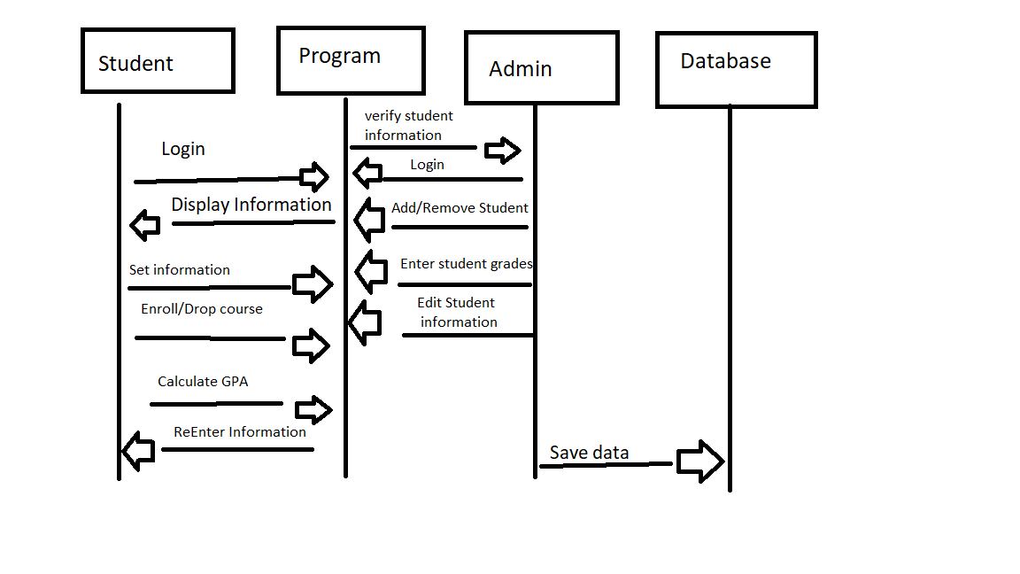

1. **Summary**

We created a project called JGradeBook using the Java programming language and the Swing API. This allowed us to create a program that has a user interface and can be used on most computers that runs Java.

We successfully completed the login system that automatically distinguishes a student user and an admin user. The login screen will load the appropriate windows, allowing student users to look at their own information and calculate their GPA, and gives administrators the ability to look at all students’ information and edit it. The admin can add and delete students’ files.